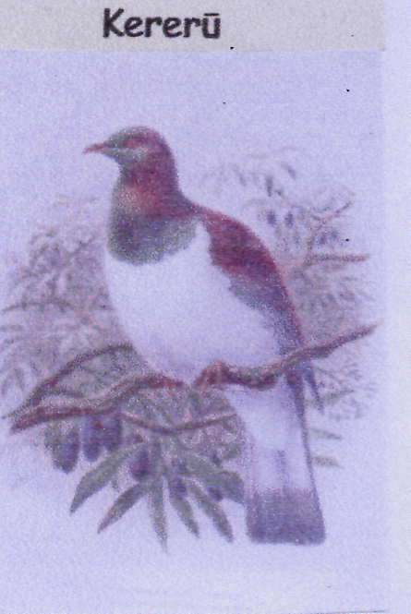
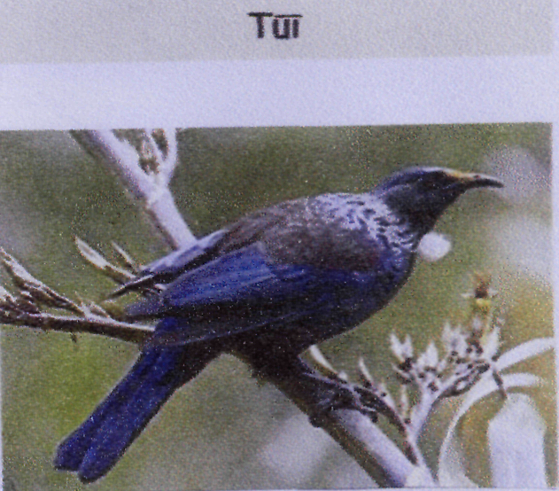
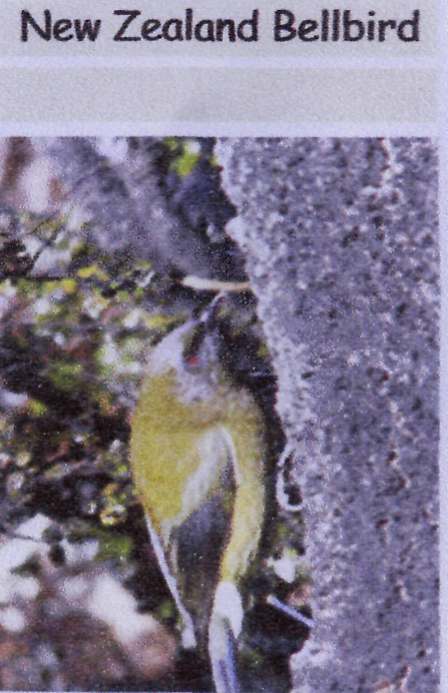
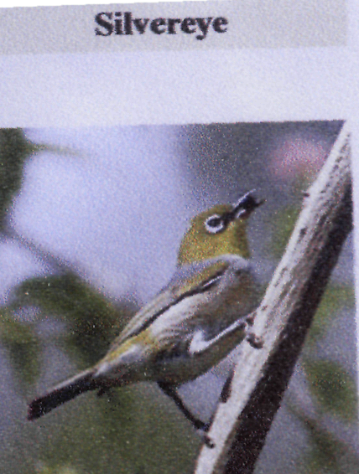

Black with white tuft at the neck. Can copy human talk.
Eat the flowers of Flax plants, but also like nectar, fruit, insects, pollen and
seeds.

Came to NZ in 1832
Nest made of grass, moss hair and spiderwebs. Hangs from small tree or shrubs. Lay2 –3 eggs. Love to eat fruit and seeds.

Native of NZ
Nest made of few twigs thrown together. Lays 1 egg up to 4 times a year.
Eat the largest native fruits, but also eat leaves and buds off trees.

Native name Korimako.
Has a bell like Song.
Nest in holes in trees
Using moss and grasses.
Loves nectar, insects
And honeydew

